Coconut/Papaya Enzyme

Facial Peel @ Aliques Skin & Body Transformation

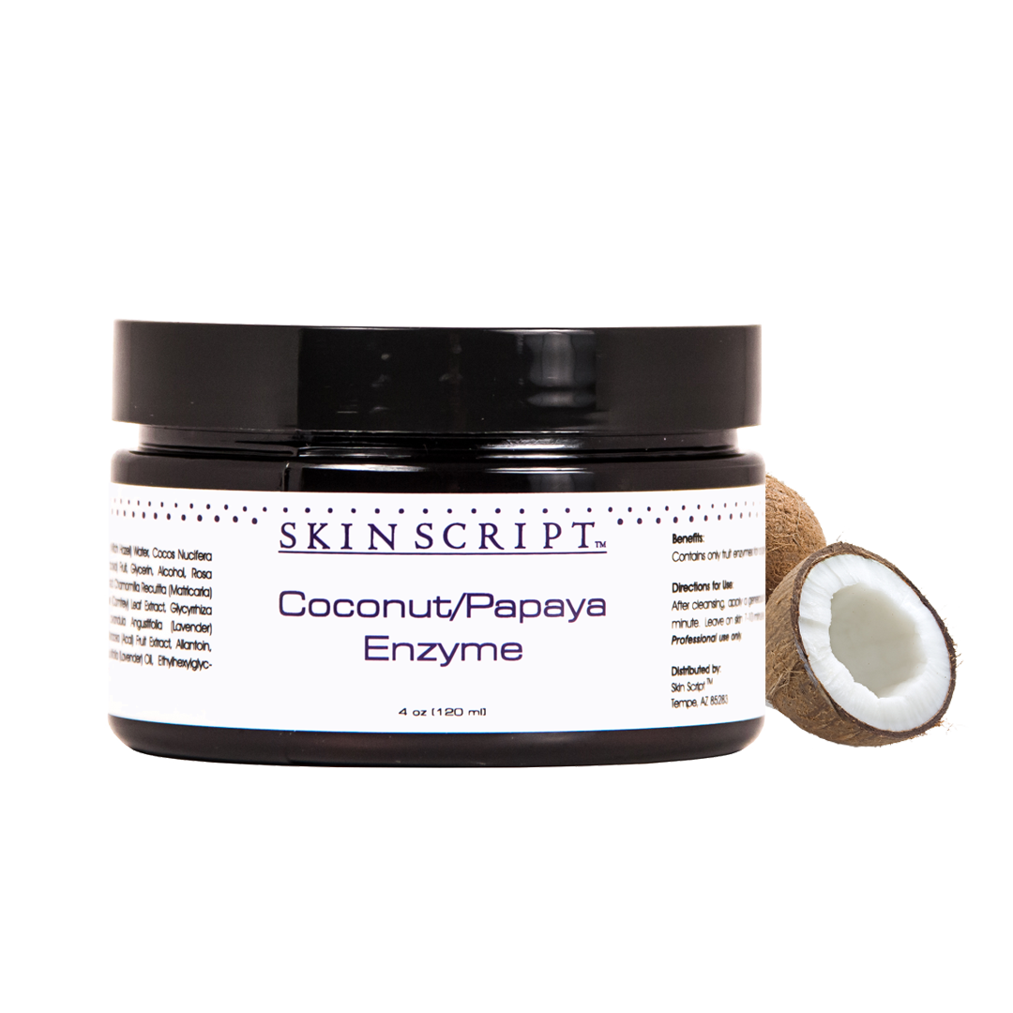

For all skin types.  Coconut and papaya enzymes dissolve dead skin cells revealing healthy soft skin. The small molecular structure of coconut allows for easy absorption through the skin giving it a soft, smooth texture. Ideal for dry, rough and wrinkled skin. Contains only fruit enzymes for a gentle exfoliation for the most sensitive skin.

FRUIT ENZYME PEELS

What is an enzyme peel and what can it do for my skin?  
  
When you hear the word "PEEL", don't fret. Typically, whenever anyone who hasn't had this type of treatment hears the term,  
they get a little squeamish. "You're going to do WHAT to my face?!" Truth is, there isn't any form of "peeling" involved. You may experience minor flaking (which is what we want) and tightness (again, what we want) but after a day or two, your skin will be more radiant, refined, polished, brighter, firmer, clearer, softer, more hydrated, evenly toned........do I need to go on? The benefits are COUNTLESS!   
  
An enzyme peel is a blend of natural fruit ingredients (enzymes) that dissolve dead skin cells, forcing the healthier/younger skin cells to shine through. This is called cellular renewal...and we want it! By speeding up the cellular renewal process, we are giving our skin a much-needed work out. Our cells renew themselves typically every 28-48 days. The younger we are, the less time it takes but the older we get, the longer our cells take to replenish themselves. So, if we don't exfoliate and resurface our skin on a regular basis, we have icky, dull, dead skin literally clogging our pores, making our complexion look older. Gross, huh? That's what I thought!   
  
Enzyme peels help with acne, black heads, congestion, melasma/sun damage/hyperpigmentation, dry/dehydrated/dull skin, anti-aging and balancing the skin. Everyone can benefit from these treatments, especially since I customize them to suit your skin's needs. Another great and important benefit is that by sloughing off those dead skin cells, it makes it much easier for your active skin ingredients to penetrate into the deeper layers of the skin, working more effectively.   
  
If you are looking for more of a "PEELING" treatment, it's always great to boost these enzymes with a glycolic acid (great for decongesting, oily/acne prone and aging skin), lactic acid (great for hydrating and lightening), kojic acid (Lightens dark spots and redness) and retinol (great for oily/congested/aging skin). This makes your treatment much more aggressive, therefore, you will experience a little more than just flaking. If I have not treated your skin before, I first need to give you a regular enzyme peel to prep your skin in order to work towards a deeper, more aggressive treatment. You will also have to follow a home care regimen that I customize for you to get the best results possible.